**Setting Up Jenkins Master on Ubuntu 16.04 Server**

**Launch a t2.small VM with 20 GB magentic root disk**

#### Install Jenkins:

#### Before you install Jenkins, add the key and source list to apt.

#### This needs to be done in 2 steps:

##### **Step 1.A : change to your home directory**

cd /home/ubuntu

##### **Step 1.B : First Add the key**

wget -q -O - https://jenkins-ci.org/debian/jenkins-ci.org.key |sudo apt-key add -

##### **Step 2.A : Create source list for jenkins**

sh -c 'echo deb [http://pkg.jenkins-ci.org/debian-stable binary/](http://pkg.jenkins-ci.org/debian-stable%20binary/) > /etc/apt/sources.list.d/jenkins.list'

##### **Step 2.B : validate source list for jenkins**

cat /etc/apt/sources.list.d/jenkins.list



##### **Step 3: Update the repo**

apt-get update

##### **Step 4 : Install jenkins**

apt-get install jenkins

##### **Step 5 : change default port number**

vim /etc/default/jenkins

#### - HTTP_PORT=8080

#### by

#### - HTTP_PORT=8090

#### - Here, 8090 was chosen but you can put another port available.

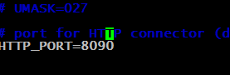

##### **Step 5 : Restart you Jenkins server**

service jenkins restart

##### **Step 6 : check status of Jenkins server**

service jenkins status

#### 

##### **Step 7 : review logs of jenkins**

#### - Log file will be placed in

tail -f /var/log/jenkins/jenkins.log

#### - *Note:* If your /etc/init.d/jenkins file fails to start jenkins,

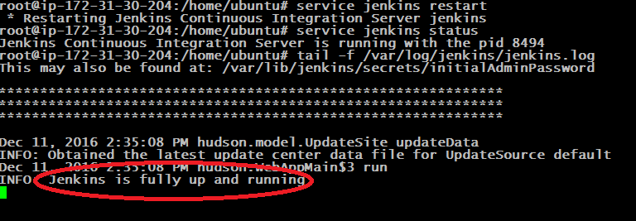

##### **Step 7 : Visit your Jenkins server on web browser http://52.15.125.49:8090/**

#### 

##### **Step 7 : ssh to your Jenkins server and fetch password**

#### Enter the password located at

cat /var/lib/jenkins/secrets/initialAdminPassword



##### **Step 8** : *go to web Browser enter the password*

#### 

##### **Step 8** : You should see dashboard **selects Install suggested plugins**

#### 

##### **Step 9** : observe the plugin installation and wait till complete

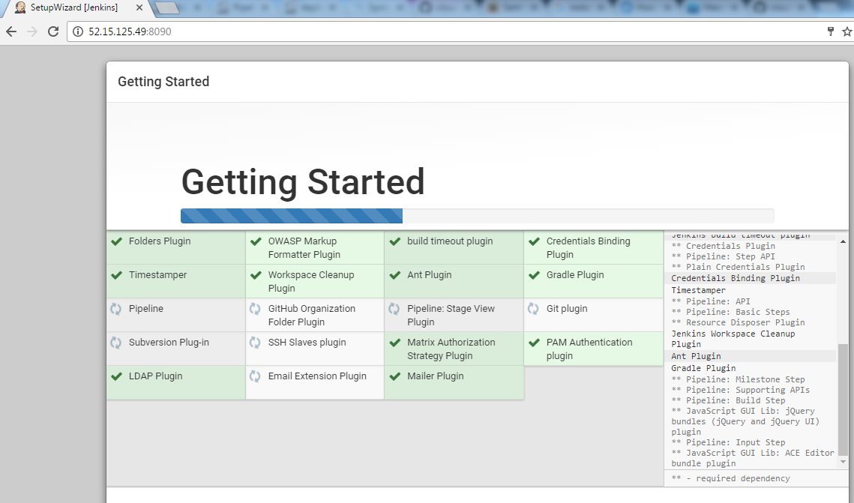

##### **Step 10** : create a admin user

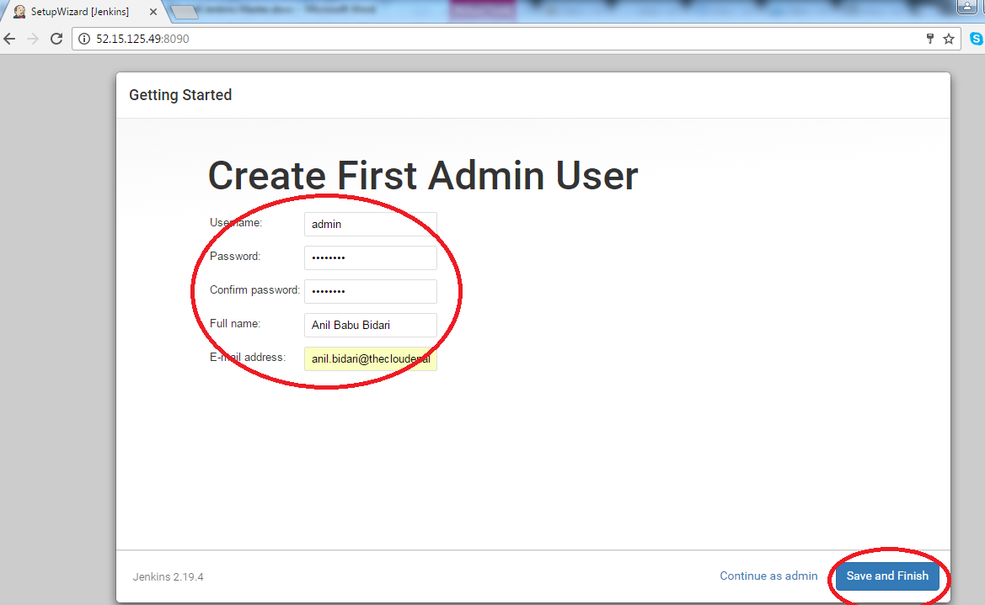

##### **Step 11** : Click on Start using Jekins

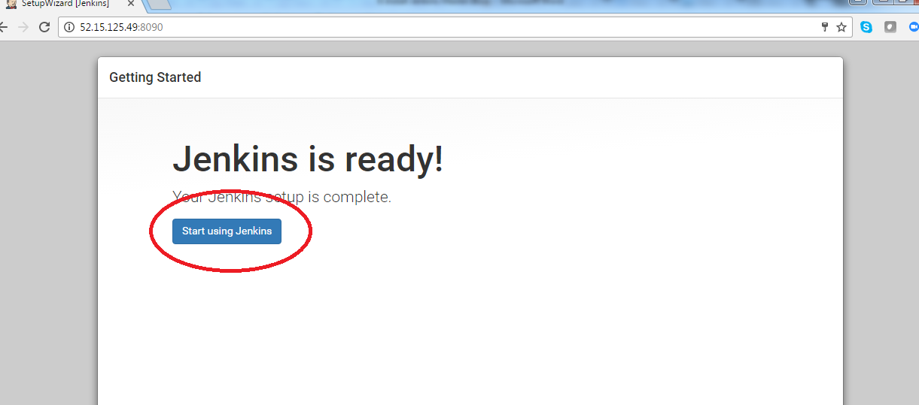

##### **Step 12** : Congratulations …..!

